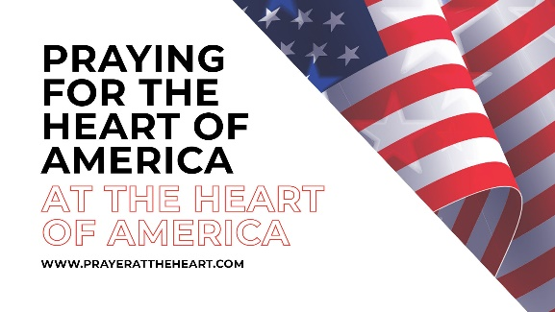
East Prayer-Route Travel Points
Harold > 706-714-4611
Kathleen > 706-988-6454

Friday, 16 July = initial meeting and overnight lodging.
Redemption Ministries Conference Center, 5201 Courthouse Road, Prince George, VA 23875.
Arrive in the afternoon at your leisure. [locals in charge: Bishop Dayton Birt, Exec admin: Joanne Wamsley]
6 p.m. = Meal together on site.
7 p.m. = Orientation and initial prayers on site.

Saturday, 17 July = First Landing State Park, Visitors center, Virginia Beach, VA 23451 (2 hr drive. $10 parking fee)
10 a.m. = prayer in the surf at First Landing Beach
12:00 = lunch at various cafes
01:00 = various prayer points in city of Virginia Beach
03:30 = Williamsburg, VA - prayer at House of Burgesses and Bruton Parish Church
Overnight at Comfort Suites, 541 Warrenton Road, Fredericksburg, VA 22406 (Front Desk 540-322-4700)

Sunday, 18 July = Union Station Parking Garage, 50 Massachusetts, Avenue NE, Washington, DC 20002 (1 hr drive.)
10 a.m. = meet at the Liberty Bell replica for corporate prayer
11:30 a.m. = split up for free-style prayer at 10 specified points.
05:30 p.m. = Church of Living Waters, 4915 Wheeler Rd, Oxon Hills, MD - Catered meal & corporate prayer.
Overnight in Winchester, VA - Comfort Inn, 195 Kernstown Commons Blvd, Winchester, VA 22602.

Monday, 19 July = depart at 08:00 a.m. for Charleston, WV (6 1/2 hr drive plus lunchtime & rolling-prayers)
Drive-thru and rolling prayers with assigned "mini-stops" and "tent-peg-prayers".
3:00 = Charleston, WV, corporate prayer on state capital steps
Take I-64 to Maysville, KY and overnight at Hampton Inn, 503 Market Place Drive, Maysville, KY 41056

Tuesday, 20 July = depart at 9 a.m. for Cane Ridge Meeting House in Cane Ridge, KY. (1 hr drive)
10 a.m. = corporate prayer at 215 yr old site of the birth of the Great Awakening.
Enroute to Evansville = Drive-thru and rolling prayers with assigned "mini-stops" and "peg-it-prayers".
6 p.m. = Evansville, IN – corporate prayer local contact & site still uncertain
Overnight at Comfort Inn & Suites, 3901 Hwy 41 North, Evansville, IN 47711. Phone: 812-423-5818

Wednesday, 21 July = depart 8:30 a.m. drive I 64 to St. Louis, MO (2 hr 45 min. drive)
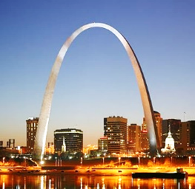
Drive-thru and rolling prayers with assigned "mini-stops" and "peg-it-prayers".
12:30 = Gateway Arch corporate prayer parking to be found
St Louis = various prayer assignments yet to be designated
(3 hr 25 min drive to Columbia)
Overnight in Columbia, MO - Comfort Suites, 1010 Business Loop 70, W. Columbia, MO 65202.
phone 573-234-6884
Thursday, 22 July = depart at 8 a.m. to Liberty, MO (2 hr drive via I-70)
10 a.m. = prayer overlooking the I-35 corridor - lunch together, then travel to Topeka, KS (1 hr 20 min drive via I-70)
3:00 = Corporate Prayer at Kansas State Capital bldg., SW 8th & SW Van Buren, Topeka, KS.
Parking at Centre City Public Parking Garage, 825 S. Kansas Avenue, Topeka, KS 66612 (2 hrs free)
4:30 = Charles Parham historic site at 335 SW Jackson Street, Topeka, KS 66615 (1st recorded glossalalia in USA) 785-783-8303
Overnight in Manhattan, KS - Comfort Suites, 1020 Hostetler Drive, Manhattan, KS 66502. phone 785-728-4044.

Friday, 23 July
12 noon = meet in Lebanon, KS for united Corporate Prayer Rally from 2-8 p.m.
Afterward, start the return journey home on your own schedule.

